SIMATS ENGINEERING
ASSESSMENT TOOL 2

COURSE CODE: CSA51 COURSE NAME: Cryptography and Network Security

COURSE OUTCOME COVERED

CO3: Examine cryptographic hash algorithms, digital signature schemes, and assess Kerberos and X.509 authentication frameworks for ensuring integrity, authentication, and non-repudiation.CO (BL4 , BL5)

Assessment Tool Weightage: 20%

QUESTIONS: 5 TOTAL MARKS: 25

Annexure A
CASE STUDY

Code of Conduct:

I ____________________ (Name / Reg No) certify that this submission is my original work and that I have adhered to the guidelines specified for this assessment.
I understand that any violation of academic integrity rules will result in disciplinary action.

Signature of the student:

Annexure A
Case Study

- A software company is using MD5 to store user passwords in its database. After a security breach, it is discovered that attackers were able to crack multiple passwords. Analyze the weaknesses of MD5 in this scenario and propose a more secure hashing approach using SHA-based techniques.

- A banking application implements digital signatures for transaction verification, but users report unauthorized transactions being approved. Analyze the possible flaws in the digital signature implementation and recommend improvements based on secure signature standards.

- An enterprise network uses Kerberos for authentication, but attackers successfully perform a replay attack to gain unauthorized access. Examine how this attack could occur and propose enhancements in the authentication process to prevent such threats.

- A secure communication system uses a simple hash function to verify message integrity, but attackers are able to modify messages without detection. Analyze why this approach fails and propose a solution using HMAC to improve message authentication.

- An organization implements X.509 certificates for secure communication, but users encounter frequent trust validation errors. Analyze the possible issues in certificate management and propose solutions to ensure proper authentication and trust chain validation.

ANSWERS:

1. MD5 Password Hashing Vulnerability
Problem:
The company uses MD5 to store passwords, but attackers cracked several passwords after a breach.
Weaknesses of MD5:
- MD5 produces only a 128-bit hash, which is no longer considered cryptographically secure.
- It is extremely fast, allowing attackers to perform billions of password guesses quickly using GPUs.
- MD5 is vulnerable to collision attacks.
- If passwords are stored without a unique salt, attackers can use rainbow tables to recover many passwords efficiently.
- MD5 was designed as a general-purpose hash, not as a password-hashing algorithm.
Recommended solution:
- Do not use plain MD5 or plain SHA-256 for password storage.
- Use a password-specific algorithm such as Argon2id, or bcrypt/scrypt/PBKDF2 when appropriate.
- If the requirement specifically asks for a SHA-based technique, use PBKDF2-HMAC-SHA-256 or PBKDF2-HMAC-SHA-512 with:
  - A unique random salt for every password.
  - A high iteration count.
  - A sufficiently long derived key.
- Store the salt and password-derived value, but never store the plaintext password.
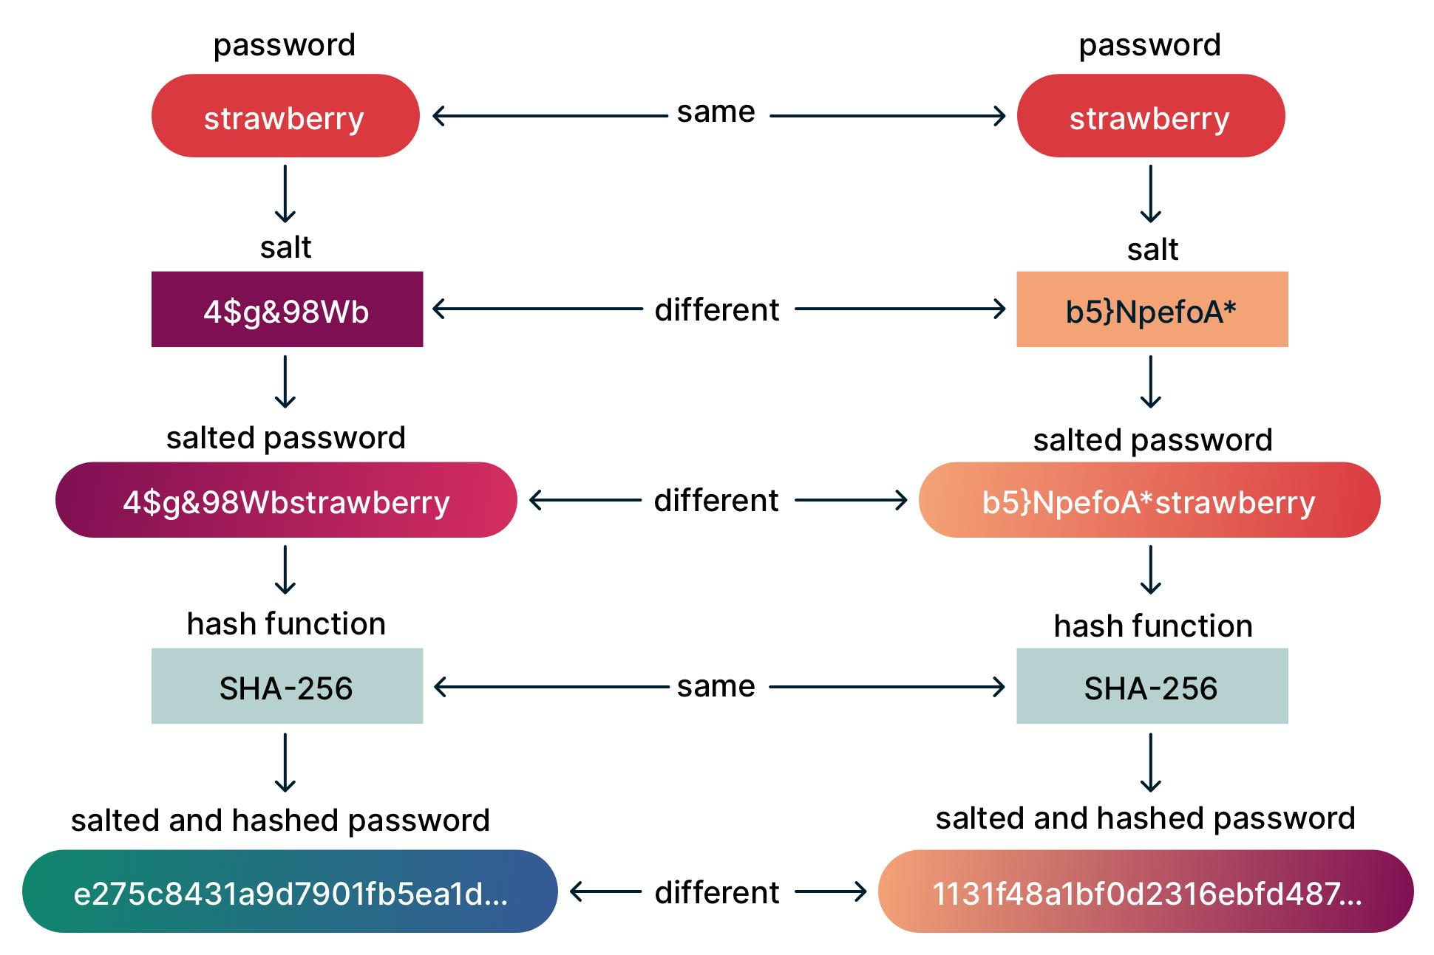

Conclusion:
Replacing MD5 with a salted, computationally expensive password-hashing scheme significantly reduces offline password-cracking attacks.

2. Digital Signature Implementation Vulnerability
Problem:
A banking application uses digital signatures, but unauthorized transactions are being approved.
Possible flaws:
- Private-key compromise – An attacker may have obtained the user's private signing key.
- Weak key generation – Predictable or insufficiently random keys can be compromised.
- Improper signature verification – The application may not correctly verify the signature before approving a transaction.
- Transaction data not fully signed – If the signature covers only part of the transaction, an attacker could modify unsigned fields.
- Replay attacks – A valid signature from an earlier transaction could potentially be reused.
- Weak algorithms or parameters – Outdated signature algorithms or inadequate key sizes may be vulnerable.
- Poor key storage – Private keys stored insecurely can be stolen.
Recommended improvements:
- Use modern standards such as RSA-PSS with SHA-256/SHA-384 or ECDSA with SHA-256, with properly selected key sizes/curves.
- Ensure the signature covers all security-critical transaction fields, such as:
  - Account number
  - Amount
  - Beneficiary
  - Timestamp
  - Transaction ID/nonce
- Verify the signature before processing the transaction.
- Protect private keys using secure hardware such as an HSM where appropriate.
- Use strong random-number generation.
- Implement timestamp/nonce checking to prevent replay.
- Rotate and revoke compromised keys.
- Maintain secure audit logs.
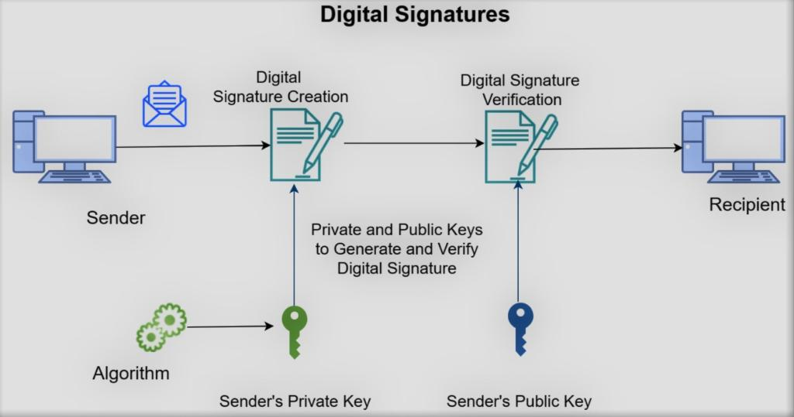
Conclusion:
Digital signatures provide authentication and integrity only when the signing keys, signed data, algorithms, and verification process are all implemented securely.

3. Kerberos Replay Attack
Problem:
The enterprise uses Kerberos, but attackers replay authentication information to gain access.
How the attack can occur:
- An attacker captures authentication data exchanged over the network.
- If a reusable authentication message or authenticator is accepted again, the attacker can resend it.
- Without proper timestamp validation, an old authentication message may be treated as new.
- Clock synchronization problems can also weaken timestamp-based protection.
- A compromised session credential or ticket can allow unauthorized access.
Kerberos protection mechanisms:
Kerberos normally uses:
- Timestamps in authenticators.
- Short validity periods for tickets.
- Session keys for secure communication.
- A trusted Key Distribution Center (KDC).
Recommended enhancements:
- Enforce strict timestamp checking.
- Maintain accurate clock synchronization using secure time synchronization.
- Use short ticket lifetimes.
- Reject previously used authenticators where applicable.
- Protect the KDC carefully because it is a central trust component.
- Use strong encryption algorithms and current Kerberos configurations.
- Immediately revoke or replace compromised credentials.
- Monitor authentication logs for repeated or suspicious ticket use.
- Use mutual authentication so both client and server authenticate each other.
Conclusion:
Replay attacks can be greatly reduced by combining timestamps, short-lived tickets, unique authenticators, secure session keys, and proper clock synchronization.

4. Simple Hash vs HMAC
Problem:
The system uses a simple hash such as:
Hash(Message)
to verify message integrity. Attackers modify messages without detection.
Why it fails:
A normal hash does not contain a secret key.
For example:
Original Message → Hash(Message)
An attacker can change the message and calculate a new hash:
Modified Message → Hash(Modified Message)
If the attacker can replace both the message and its hash, the receiver has no way to determine whether the message came from a trusted sender.
A hash provides integrity checking against accidental changes, but by itself it does not provide message authentication.

Solution: HMAC
Use:
HMAC(K, Message)
where:
- K = secret key shared by sender and receiver
- Message = original message
- HMAC = Hash-based Message Authentication Code
For example:
Sender:
Message + HMAC-SHA-256(SecretKey, Message)
↓
Network
↓
Receiver:
Recalculate HMAC using SecretKey
↓
Compare both HMAC values

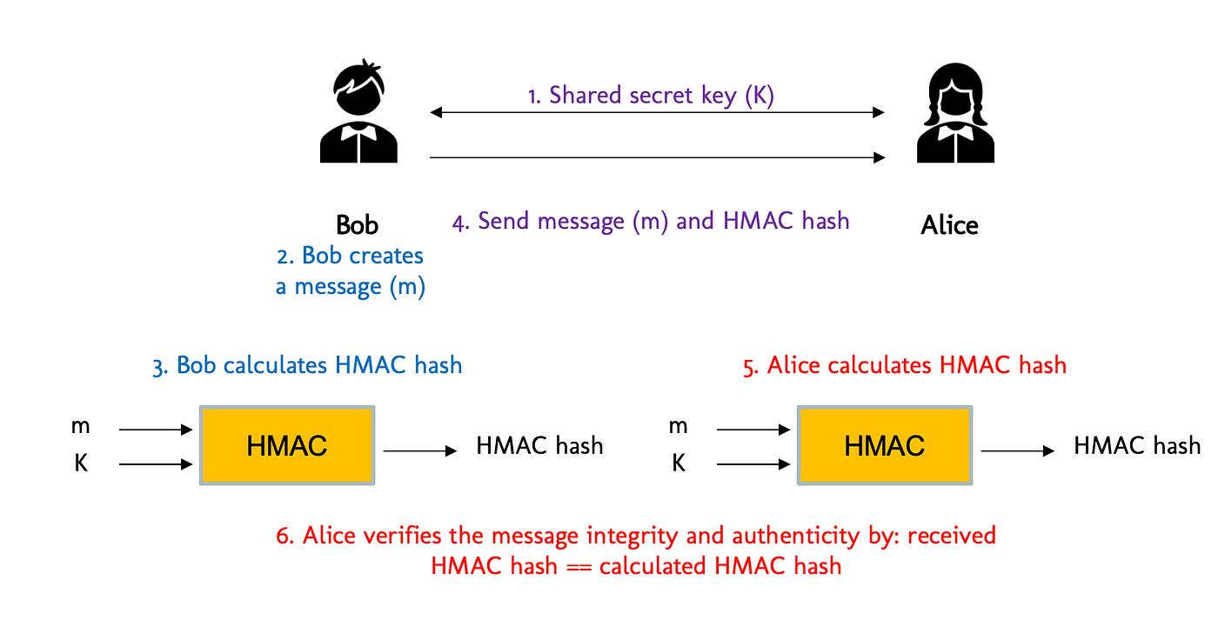
Advantages of HMAC:
- Provides message integrity.
- Provides authentication.
- Attackers without the secret key cannot generate a valid HMAC for a modified message.
- Use HMAC-SHA-256 or HMAC-SHA-512 rather than obsolete hash algorithms.
Conclusion:
A simple hash should be replaced with HMAC-SHA-256/HMAC-SHA-512 when authentication and integrity against an active attacker are required.

5. X.509 Certificate Trust Validation Errors
Problem:
An organization uses X.509 certificates, but users frequently receive certificate trust errors.

Possible causes
1. Expired certificate
- The server certificate may have passed its validity period.
2. Certificate hostname mismatch
- The domain requested by the user does not match the certificate's Subject Alternative Name (SAN).
3. Untrusted CA
- The certificate may have been issued by a CA that is not trusted by the client's trust store.
4. Missing intermediate certificate
- The server may fail to provide the required intermediate CA certificate.
5. Incorrect certificate chain
- The certificate chain may contain an incorrect or improperly configured CA relationship.
6. Revoked certificate
- The certificate may have been revoked because its private key was compromised or for another security reason.
7. Incorrect system time
- If the client's clock is incorrect, a valid certificate can appear expired or not yet valid.
8. Incorrect key usage
- The certificate may not permit the intended operation, such as server authentication.

Recommended solutions:
- Use certificates issued by trusted Certificate Authorities.
- Configure servers to provide the complete certificate chain, including necessary intermediate certificates.
- Regularly monitor certificate expiration dates.
- Ensure the hostname matches the certificate SAN.
- Maintain updated client root CA trust stores.
- Implement proper certificate revocation checking using CRL/OCSP as appropriate.
- Protect CA and private keys securely.
- Automate certificate renewal where possible.
- Ensure systems have accurate time synchronization.
- Use appropriate TLS versions and secure cryptographic algorithms.

Trust chain
A typical chain is:
Root CA
↓
Intermediate CA
↓
Server Certificate
↓
Server / Website
The client validates the server certificate back to a trusted root CA.

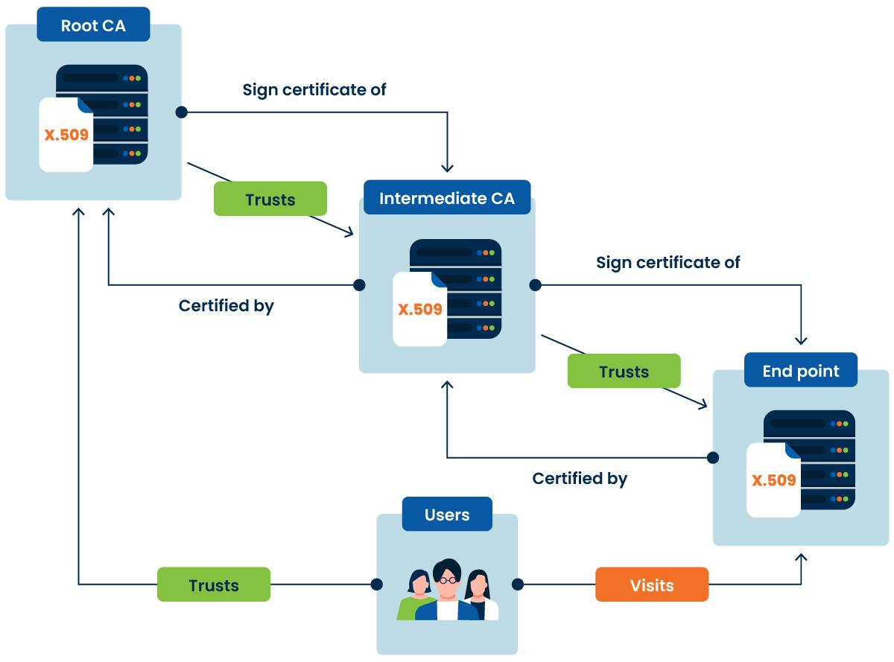

Conclusion:
Proper certificate lifecycle management, complete certificate chains, trusted CA configuration, hostname validation, revocation checking, and accurate system time are essential for reliable X.509 authentication.

RUBRICS FOR CALCULATION:

Criteria | Weightage | Level 4 – Exemplary | Level 3 – Proficient | Level 2 – Developing | Level 1 – Beginning
Understanding of Case | 25 | Thorough understanding; clearly identifies all key issues | Good understanding with most issues identified | Basic understanding; some issues missed | Poor understanding; problem not identified correctly
Application of Concepts | 25 | Effectively applies relevant concepts to analyze the case deeply | Applies appropriate concepts with minor gaps | Limited application of concepts | Fails to apply relevant concepts
Analysis | 20 | In-depth analysis with strong reasoning and insights | Good analysis with logical reasoning | Basic analysis with limited depth | Weak or no analysis; lacks reasoning
Solution Design | 20 | Innovative, feasible solutions with strong justification | Logical solutions with adequate justification | Basic solutions with weak justification | Incorrect or no solution provided
Clarity | 10 | Clear, well-structured, and easy to understand | Organized and understandable presentation | Limited clarity and structure | Poor clarity; difficult to understand

